Experiment Report

311552024 詹偉翔

1. Introduction

In this lab, we will implement the EEG classification that is EEGNet and DeepConvNet. Moreover, we will change the inside activation function with ReLU, LeakyReLU, and ELU. To see which combination will be the best model with highest accuracy.

1. Experiment Setup
2. The detail of my model

I set the parameters below:

* learning rate = 0.0007
* batch size = 1024
* epochs = 1000
  1. EEGNet

This is one of popular models to solve EEG classification problem. There are three convolution blocks : Firstconv , Depthwisedconv, and separableconv. The filter is more than previous blocks in convolution blocks. The whole architecture is the same as the architecture that TA provides.

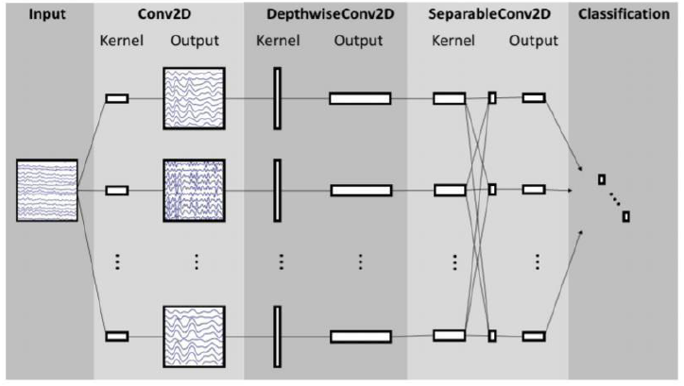

This is architecture of EEGNet.

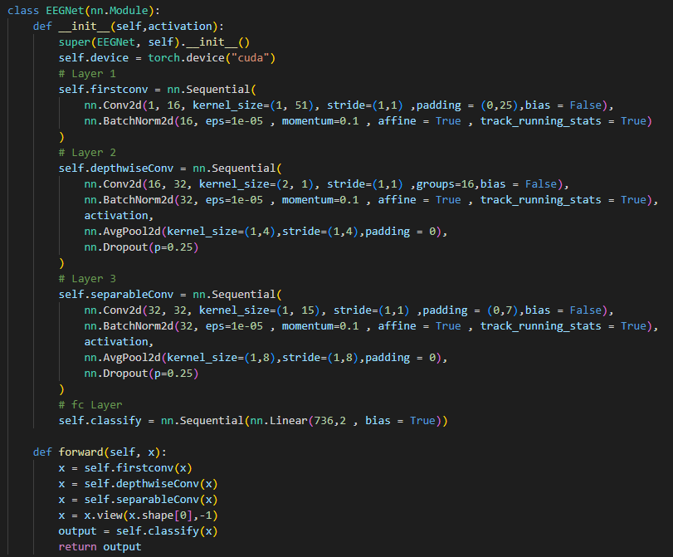

Here is my code.

* 1. DeepConvNet

It is used to compare with EEGNet. There are more layers about 5 convolution blocks and more parameters in the DeepConvNet, so it need more time to training, and I believe that if we have enough time, this model will be better than EEGNet. The architecture in my program is the same as the below architecture.

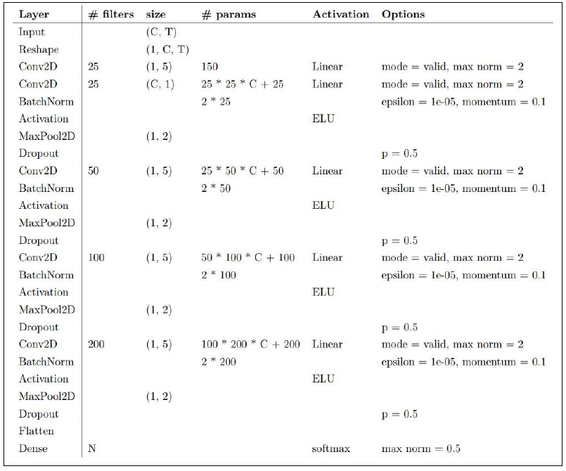

The architecture of DeepConvNet is this, where C = 2, T = 750, and N = 2.

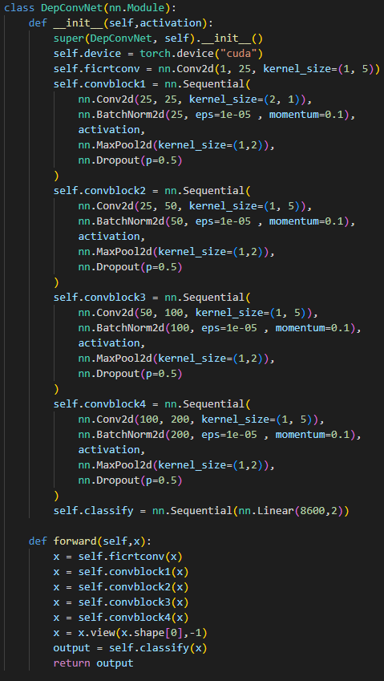

Here is my code.

1. Explain the activation function

The activation function is used to make the linear function become non-linear function.

* 1. ReLU

Relu : max(0,z), is one of the most used activation function. It is has the advantage as the sigmoid, but it is easier to calculate.

There are some problem of it, that is when z is below than 0, the weights can’t be update!

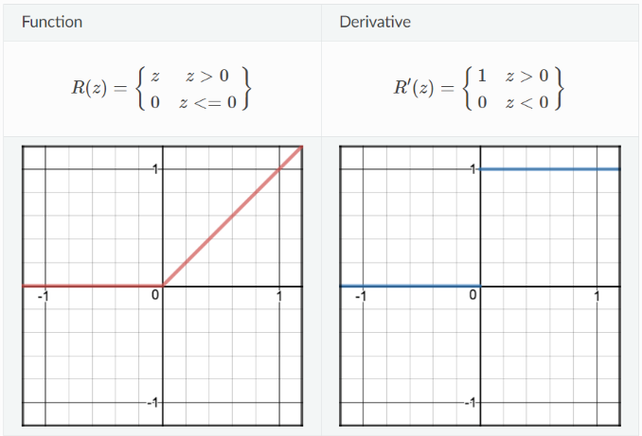

* 1. LeakyReLU

It is the ReLU’s brother. It solve the problem of ReLU, that is ReLU can’t update weights when z < 0. Also, It can be calculated as negative number. But it is most like a linear function, it can’t be used in complex classify problem.

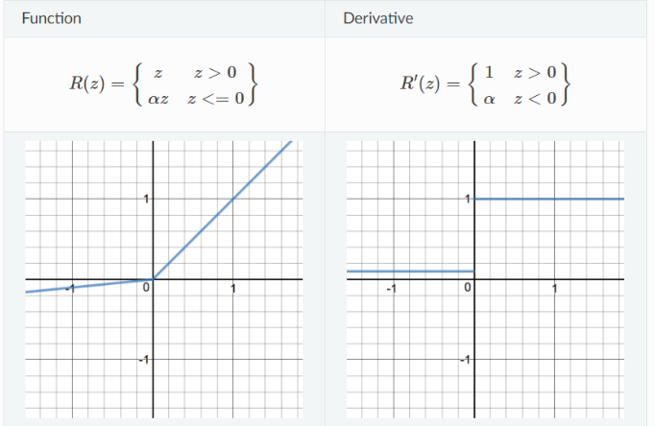

* 1. ELU

It smooth more slowly than ReLU and it also has a alpha can decides its curve when z <=0. Moreover, it is the same as LeakyReLU, that is it can output negative number.

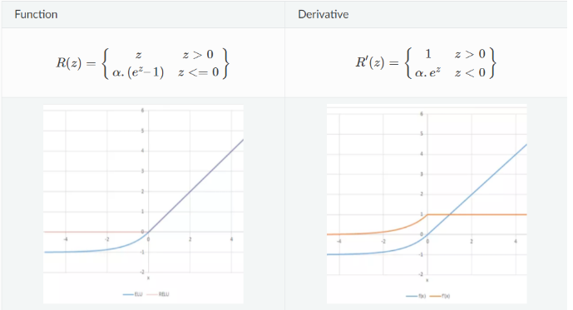

1. Experiment Result
   1. The highest testing models

|  |  |  |  |
| --- | --- | --- | --- |
|  | ELU | ReLU | LeakyReLU |
| EEGNet | 82.12% | 87.59% | 86.30% |
| DeepConNet | 80.46% | 82.5% | 82.59% |

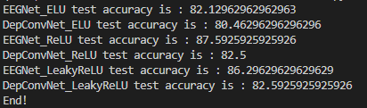

* 1. Comparison figures
     1. EEGNet

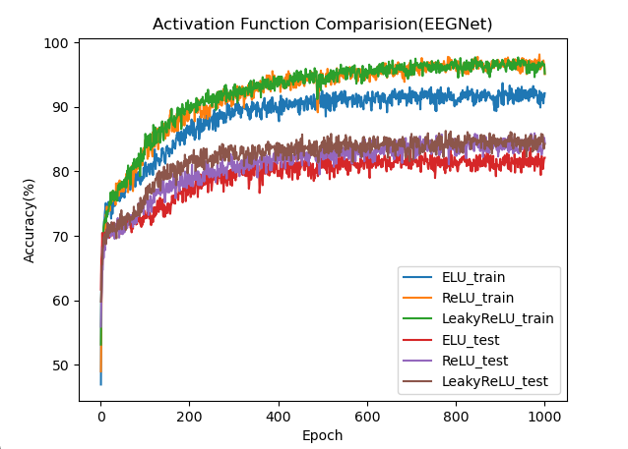

* + 1. DeepConvNet

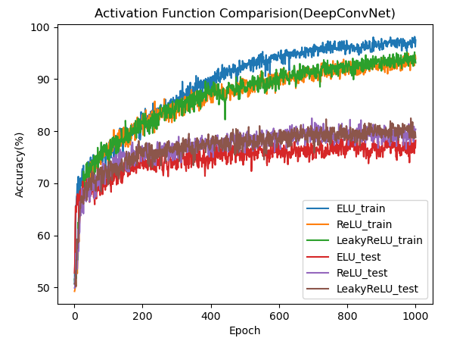

1. Discussion

There is unexpected that the performance of DeepConvNet is worse than the performance of EEGNet. I thought maybe the epochs is not enough to make DeepConvNet converge or this model isn’t fit to this dataset.

But still the learning curve is expected, the more layers model will cost more time to converge.

1. Source
   1. https://ml-cheatsheet.readthedocs.io/en/latest/activation_functions.html